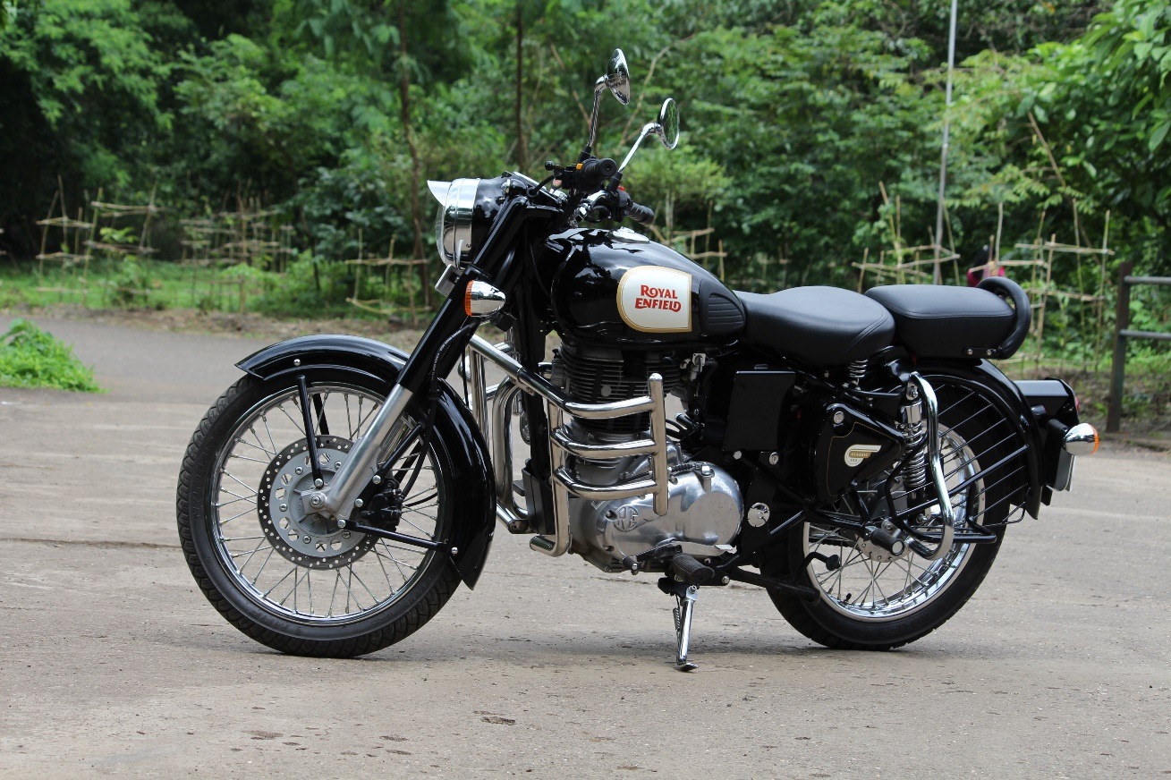

The Royal Enfield Bullet was initially an overhead valve, single-cylinder, four-stroke motorcycle made by Royal Enfield in Redditch, Worcestershire, now produced by Royal Enfield (India) at Chennai, Tamil Nadu, India. A company originally founded by Madras Motors to build Royal Enfield motorcycles under the licence of India.

The heart of the Bullet 350 is more than just metal and machinery. It’s strength, stoicism and pure soul. All of this remains unchanged even as the motorcycle shifts on to our J-platform. A brand-new 349cc engine delivers dollops of torque, even down low on the rev range, and a crystal clear thump that hits the spot every single time.

The kerb weight of Royal Enfield Bullet 350 is 195 Kg. Royal Enfield Bullet 350 ex-showroom price starts from Rs 1.73 Lakh in Delhi. Explore all 4 variants of Bullet 350 for the engine cc, fuel types, transmission options and ex-showroom prices in your city.